1. Write a JavaScript function to delete rows to a table with HTML script.

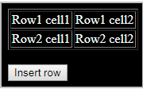

2.Write a JavaScript function that accept row, column, (to identify a particular cell) and a string to update the content of that cell

